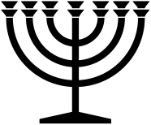 |  | May 2024
Sunday | Monday | Tuesday | Wednesday | Thursday | Friday | Saturday
 |  |  | 1 | 2 | 3 | 4
 |  |  | S
5 | 6 | 7 | 8 | 9 | 10 | 11
 |  |  | S | NM | NM
12 | 13 | 14 | 15 | 16 | 17 | 18
 |  |  |  |  | S
19 | 20 | 21 | 22 | 23 | 24 | 25
 |  |  |  |  | 2nd Passover (After Previous Sunset)  S | 2nd ULB-2
26 | 27 | 28 | 29 | 30 | 31
2nd ULB-3 | 2nd ULB-4 | 2nd ULB-5 | 2nd ULB-6 | Last Day of 2nd Unleavened Bread | S
RED = Sabbath BLUE = New Moon YELLOW = High Day GREEN& YELLOW = Days of Unleavened Bread www.hope-of-israel.org

