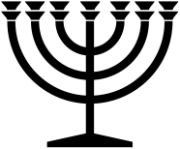 |  | March 2024
Sunday | Monday | Tuesday | Wednesday | Thursday | Friday | Saturday
 |  |  |  |  | 1 | 2
3 | 4 | 5 | 6 | 7 | 8 | 9
 | S
10 | 11 | 12 | 13 | 14 | 15 | 16
 | S | NM
17 | 18 | 19 | 20 | 21 | 22 | 23
 |  | S | Vernal Equinox
24 | 25 | 26 | 27 | 28 | 29 | 30
 |  | S
31
RED = Sabbath BLUE = New Moon www.hope-of-israel.org

